A tree rooted at node 0 is given as follows:

* The number of nodes is nodes;
* The value of the ith node is value[i];
* The parent of the ith node is parent[i].

Remove every subtree whose sum of values of nodes is zero.

Return *the number of the remaining nodes in the tree*.

**Example 1:**

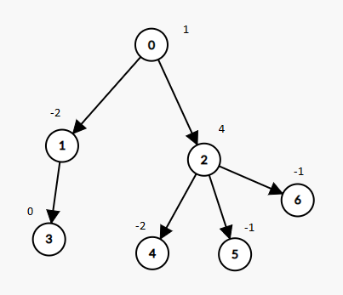

**Input:** nodes = 7, parent = [-1,0,0,1,2,2,2], value = [1,-2,4,0,-2,-1,-1]

**Output:** 2

**Example 2:**

**Input:** nodes = 7, parent = [-1,0,0,1,2,2,2], value = [1,-2,4,0,-2,-1,-2]

**Output:** 6

**Constraints:**

* 1 <= nodes <= 104
* parent.length == nodes
* 0 <= parent[i] <= nodes - 1
* parent[0] == -1 which indicates that 0 is the root.
* value.length == nodes
* -105 <= value[i] <= 105
* The given input is **guaranteed** to represent a **valid tree**.